

Figure 1: Adaptive Procedural Template checklist / Standing on the shoulders of giants

TITLE: Eco Economic Epochs for DATF Distributed Autonomous Trade Federations / DAOs, programmable $$$, the programmable Economy

VISION STATEMENT: We can synchronize ourselves in time-space for common goals e.g., code an equitable, sustainable, distributed programmable economy among a DATF Distributed Autonomous Trade Federation on the cryptocurrency blockchain

Minimum essential requirements for Trade Federations on the cryptocurrency DLT Distributed Ledger Technology blockchain (partial listing):

* GDP Gross Domestic Product Index / statistical mean value index-based TRC Trade Reference Currency using demurrage fees
* Geo-spatial temporal metrics, and meters i.e. storing increments of value for all things internet, internet of $$$ into the “blockchain cube”
* Ecologically sustainable Economic Epochs applying geospatial temporal methods and means i.e., IDMaps - SonarHops, Ericsson Erlang time algorithms / time equations to base economic incentives, derive TRC Trade Reference Currency demurrage charges i.e., closer is cheaper given closer = less fuel, less time, less demurrage fees to compensate for distance traveled, time spent going to market
* Universal meme for Consensus algorithm interoperability, synchronization
* OPSCODE brevity code syntax / symbol set lexicon of tokenized GDP Gross Domestic Product pacing items described in a syntax lexicon library promoting interoperability Rosetta Stone syntax lexicon library needed for Artificial Intelligence man - machine interface
* Universal heartbeat message event / transaction QRNB Quantum Random Number Beacon non-repudiation bus, Time-space synchronized Universal Time Zone UTZ stochastic harmonization using a firefly inspired heartbeat algorithm / heartbeat message event - transaction bus
* Quantum computing mediation, mitigation among the quantum haves, have nots i.e., percentage of HFT High Frequency Trade stock, commodities, cryptocurrencies, crypto currency synthetics, Central Bank Digital Currencies / DeFi DAO exchanges - grass root federations
* Big data sync, time – space metrics and meters descriptive framework based on geo-spatial temporal time – space stamp methods to establish time - space Epochs i.e., IDMaps - SonarHops, Ericsson Erlang time equations

GOAL: We have a clear and present opportunity to improve temporal, geo-spatial, syntactic - semantic consistency, interoperability among myriad programmable money memes among an equitable, programmable trade federation economic framework.

PATENT APPLICATION TYPE: Adaptive Procedural Template USPTO 13/573,002: Time-Space Meter / Syntax Lexicon Rosetta Stone, Checklist: adaptive procedural template in patent application terms does not capture attention so graphics are used as a picture representing a checklist of useful tools, procedures, processes, algorithms, ideas that a trade federation would agree to use to achieve, maintain their collective goals of the distributed federation. The Heart Beacon Cycle Time - Space Meter Adaptive Procedural Template checklist of useful tools, procedures, products, algorithms, econometrics, processes, metrics, meters, e.g., time - space, geo-spatial, temporal, cryptocurrency data storage into a "blockchain cube" with height, width, depth, volume, programmable money metrics, meters for a myriad of memes, metaphors.

PATENT APPLICATION USPTO 13/573,002 The Heart Beacon Cycle Time  - Space Meter is an adaptive procedural template / checklist of ideas, methods, processes, procedures, algorithms, tools… used to organize diverse peoples speaking many different languages through the universal language of symbols into Distributed Autonomous groups organized in time - space to achieve common goals among individuals organized into federated groups in DAO (s) Distributed Autonomous Organizations - a RAND Corporation term (DoD funded Think Tank) circa 2001. Each item in the procedural template checklist links to detailed treatise that includes expansive description

Method: Code Eco sustainable incentives into programmable economic framework reusing / leveraging NATO systems of systems engineering best practice. Form federations of Distributed, Autonomous Organizations DAO communities, states, sovereign nations using an adaptive procedural template checklist promoting organization and synchronization among geo-spatially and temporally dispersed groups using a common syntax – symbol set lexicon. Federated groups activities are synchronized geo-spatially across time - space to achieve synergy, synchronicity of events orchestrated from micro to macro cycles from grassroots to capitals.

1. Reuse OPSCODE brevity codes mapped to message symbol sets enabling Artificial Intelligence / human interaction ( i.e., man — machine interface).
2. Apply lessons learned (bandwidth discipline, interoperability, OPTEMPO sync cycles... intrinsic to NATO SOP swords to plowshares following German military proposal use cases circa 2003.

THESIS: All things internet, internet of programmable money are formed using:

1. Time epochs created by oscillating quartz crystal based silicon chips
2. Syntax used / not used as programming instructions during epoch time cycles

All things internet, net of money blockchains are formed by unicast, multicast, anycast protocols. Programmable money’s improvements are in cryptography. Blockchains are formed by unicast, multicast, anycast and workflow filters. Programmable money’s improvements are in cryptography. Internet 3.0 and the new web will be based on the original structure described by Stanford University. There are no packets, frames, layers, blocks, shards, graphs, hash graphs “bots”, “motes”, … or Satoshi's traversing the net, stored in a blockchain cube. Transactions are unicast, multicast, or anycast (workflow).

The above cited memes made up terms are non - compliant US Supreme Court SCOTUS Alice Corp Vs CLS Bank 2014 ruling “claims may not direct towards abstract ideas”, Note: Physical is the opposite of abstract considering SCOTUS Alice 2014 ruling and in light of the fact that NIST’s National Institute of Standards and Technology QRNB Quantum Random Number Beacon is based on light photonics.

THREE OPTIONS: one world government’s one world currency:

1. IMF's International Monetary Fund SDR Special Drawing Rights stable coin basket
2. NESERA / GESERA's QFS Quantum Financial System ground station in Las Vegas
3. Department of Commerce - Treasury – NIST QRNB at Boulder Colorado (Stephen King's Book The Stand's Free Zone)

PRECEDENT: Nobel Prize winning economist Milton Friedman's K% rule is a GDP Gross Domestic Product economic heartbeat, a GDP pulse. Apply a Quantum Random Number Beacon QRNB for non-repudiation at any location / time in the future = basis for a one world economic system of systems unit of value FEDCOIN, World Coin

PRECEDENT: GDP INDEX ECONOMY: Thomas Edison and Henry Ford proposed a currency based on a basket of crop commodities. Edison believed that crops held their value over time - enter climate change reality and the merits are self-evident.

PRECEDENT TRADE REFERENCE CURRENCY TRC / FRENCH MONEY OF PEACE: Later in the 1990's, Belgian Economist Bernard Lietaer proposed a commodity based TRC Trade Reference Currency based on demurrage charges to support logistics of goods moved from supplier to consumer called the TERRA TRC. Prior to his passing, Nobel Prize winning economist Milton Friedman described an "economic heartbeat" in his K% rule where the Treasury increases the money supply increases and decreases pegged to the GDP index. Nations / the world's economy would be managed as a composite value index like for example, Vanguard's index funds, commodity index funds.

PRECEDENT: NOBLE PRIZE-WINNING ECONOMIST: Milton Friedman’s K% rule as an “economic heartbeat”. K-Percent Rule DEFINITION: The K-Percent Rule proposal by economist Milton Friedman was the central bank should increase the money supply by a constant percentage every year. The K-Percent Rule proposes to set the money supply growth / reduction at a rate equal to the growth of real GDP each year. K-Percent Rule — Investopedia <http://www.investopedia.com/terms/k/k-percent-rule.asp>

PRECEDENT: NOBEL PRIZE WINNER Simon Smith Kuznets gross national income (GNI), previously known as gross national product (GNP), is the total domestic and foreign output claimed by residents of a country, consisting of Gross Domestic Product (GDP), plus factor incomes earned by foreign residents, minus income earned in the domestic economy by nonresidents (Todaro & Smith, 2011: 44).[2] Comparing GNI to GDP shows the degree to which a nation's GDP represents domestic or international activity. GNI has gradually replaced GNP in international statistics. Kuznets became the first economist to show that the Absolute Income Hypothesis gives inaccurate predictions in the long run by using time-series data. Wikipedia <https://en.wikipedia.org/wiki/Simon_Kuznets>

PRECEDENT: WORLD ECONOMIC FORUM WEF ENHANCED GDP: the World Economic Forum has proposed a scorecard made up of four dimensions that need to be brought into balance: prosperity, the planet, people and the role of institutions.

Prosperity vs economic growth. The World Economic Forum’s ‘Prosperity’ metric includes aspects such as social mobility, income or wealth inequality and financial resilience. GDP still features within the Prosperity dimension updated to reflect different dynamics within the world economy. WEF: <https://www.weforum.org/agenda/2021/05/gdp-new-measure-economic-growth/>

PROJECT BEACON: Reuse NATO's system of systems syntax lexicon OPSCODE brevity code structured data exchange, heartbeat micro to macro cycle Universal Time Zone UTZ sync to support an EIN Earth Intelligence Network neural net emulation. Support Beacon Communities with an open-source Earth Intelligence Network EIN integrated with a quantum random number beacon blockchain for event, transaction non-repudiation at any place – time in the future . METHOD: A snapshot or sync delta value taken at a predetermined time interval (micro-cycle to macro cycle) to determine the statistical mean value of the goods, commodities that comprise a GDP index is performed and used as the value of the organization's / nation's / world's unit of value as the basis for currency exchange. This process reuses DARPA / NATO's Battlefield Digitization, Net Enabled Operations NEO procedures that have supported the Pentagon's / NATO's digital dashboards since the 1990's.

NATO has invested decades of mapping OPSCODE brevity codes to symbology / symbols / symbol sets contained in three hundred 300 plus message set / use cases as part of Battlefield digitization, Net Centric Warfare NET Enabled Operations NEO NETOPS system of systems engineering. Blockchain, crypto currency developers are recreating, reinventing this decades old, tedious, time intensive, labor intensive, expensive structured data exchange wheel with every new meme, metaphor.

NATO SYSTEM OF SYSTEMS ENGINEERING REUSE: NATO has invested decades of mapping OPSCODE brevity codes to symbology / symbols / symbol sets contained in three hundred 300 plus message set / use cases as part of Battlefield digitization, Net Centric Warfare NET Enabled Operations NEO NETOPS system of systems engineering. Blockchain, crypto currency developers are recreating, reinventing this decades old, tedious, time intensive, labor intensive, expensive structured data exchange wheel with every new meme, metaphor. Crypto economics needs a universal syntax lexicon digital base Artificial Intelligence A.I., quantum blockchain heartbeat beacon to synchronize, sample tokenized commodities across a stochastically harmonized UTZ Universal Time Zone using the firefly-heartbeat algorithm and Princeton University Mathematician John Nash’s Equilibrium algorithms NATO bases are small cities that transact most goods, commodities with the host nation. Why reinvent the syntax lexicon Rosetta Stone wheel? This is a system of systems tool to accelerate creation of an EIN Earth Intelligence Net SOURCE: Project #UNRIG by Robert David Steele

REUSE 1: A systemic, adaptive, procedural template method used to improve synchronization in metrics, metering using </Org_ID>, {“URN”} XML data tags in signaling during heartbeat micro-cycles prior to data fusion center entry consisting of iterative heartbeat cycle metrics, meters reporting where state meta data heartbeat snapshot recalculations are performed at off site connectors that are signaling relays performing recalculation, syntax processing during macro-cycle epochs reconciling dissimilar standards, data syntax formats that are then reported signaled, news casted, beacon broadcasted to distributed organization applique overlay displays

REUSE 2. A adaptive procedural template used to improve signaling, synchronization using TCP/IP heartbeat time stamping occurring during micro-cycles of state meta data prior to data fusion center entry among metrics, metering processes comprised of TCP/IP heartbeats, heartbeat messages signaled during micro-cycles scheduling instructions, commands, processes, procedures, algorithms, telemetry instructions for example, to master-controller processes i.e., block, start, stop, pause, resume, set Time To live TTL i.e., stock market high frequency flash trade, currency, interest rates, tax rates, time banking, cloud computing commodity exchanges, big data, electrical micro-grid, fungible goods, real time bidding, many use cases. Summary: Time stamping and applying descriptive data type tags to heartbeat state meta data after data is collected and queued, stored in temporary structures or entered into data base instantiations after the fact is problematic. All internet supported devices including high frequency stock, currency, commodity etc., flash trade master controllers receive heartbeats. Heartbeats are silicon chip created intervals, epochs, time cycles used to (not) process syntax.

REUSE 3. A systemic adaptive procedural template method improving stochastic networks harmonization through use of timing, synchronization intrinsic to TCP/IP heartbeat / heartbeat message signaling using set, scheduled, epochs in micro-cycles in combination with firefly insect signaling stochastic harmonization algorithms where firefly protocol sample means are matched with closest heartbeat sync delta micro-cycle report values to recalculate statistical averages, means signaled through off site connector conversion, recalculation gateways that news-cast, beacon broadcast to subscribers monitoring macro-cycle reports that heretofore would not exist without following the Heart Beacon Cycle procedural template as guides for reporting thus improving temporal harmonization in metrics and metering of stochastic telecommunication mesh fabrics grid control planes over wide areas in cases involving issues in terms of consistency, reliability, traceability, positive organizational identification, temporal transaction fidelity, event, alert predictability, data analytics, network forensics real rime bidding, stock market exchange floor server co-location verses servers distantly located, fluctuations in interest rates, currency exchanges, double payment adjudication, fungible good trading stochastic harmonization, electrical power micro-grids, cloud computing, "big data"...

REUSE 4. A systemic adaptive procedural template method using time stamping and signaling intrinsic to TCP/IP heartbeat, heartbeat sync delta snapshot message signaling to improve dynamic, adaptive organization change management using XML <ORG_ID> network service interface NSI templates updating self-organizing process templates i.e., directory service, reporting, map, network, system of systems effecting changes in directory structures database MIB i.e., network subnet joins, moves, splits drops, adds as alternatives to mergers, acquisitions effecting changes responsive to leader’s actions, decisions i.e., mission-aware networking, network centric operations improving agile, ad hoc organizational business operations course of actions selection by organizations registered for more than one <ORG_ID) improving action / reaction to change. Use cases: network moves, adds, joins, splits, drops used instead of formal merger, acquisition

REUSE 5. A systemic adaptive procedural template method improving search engine methods using heartbeat, beacon signaling, <ORG_ID>, , <class_types>, Paul Revere, water drop in pond meme metric recalculations occurring at off site connectors, conversion relay gateways where detection of trigger point function recalculations of state meta data set aggregations are used to detect threshold fluctuations by resource , , quantity, availability duration etc., further used to improve geo-spatial temporal descriptive mapping methods, changes in clusters of objects, entities, artifacts i.e., location, epoch time stamp geo-spatially, temporally, used to locate, search, then group into virtual collections using <data_tags> i.e., in spatial econometric, volumetric operations within network mesh fabrics triggering news-casting invitations to join equitably metered federated group arbitrage events, activities that are triggered by internet search operations improving collaboration, metrics and metering in for example, commodity, fungibles trading, resource pooling, crowd sourcing, economics.Summary: Physical linear – sequential “Paul Revere” meme used given TCP/IP internet “hops” are abstractions ineligible for patent protect. Water drop in pond physical metaphor describes geospatial temporal intensity in omni-directional, circle, radius type situations. Naval sonar meme explains geo-spatial temporal intensity metrics, meters. TCP/IP “ping” is an abstraction.

REUSE 6. A systemic adaptive procedural template method used to improve handicapped / information alerts, events, methods reliant on heartbeat timing, signaling synchronization of state meta-data improved using Paul Revere, water drop in pond memes to create, calculate radius, intensity metrics viewed as geo-spatial, temporal intensity effects i.e., visual light bar tabs i.e., stock exchange candlestick charts, audible tone, vibration-tactile situational awareness alerts by correlating tone based messaging precedence XML where lower / higher precedence settings equate to lower / higher audible tones, tactile vibrations for deaf where fewer / greater number of light tabs lit correlates, corresponds to priority, precedence further used in alert triggers of threshold fluctuations displayed in appliqué overlay graphics as metrics, meters. Reference: Describes reuse of structured military messaging’s precedence system to support for example, processing of Named Data Networking distance, interest packets by numeric precedence. This method is effective among machine to machine (Internet of Things).

REUSE 7. A systemic, adaptive procedural template method using heartbeat signaling, time stamp record keeping processes of state meta data described, typed by organizations, resources typed by Uniform Resource Name, further improved through use of Paul Revere, Water Drop in Pond memes to quantify, describe unused resources with unmet needs by performing recalculations of state meta-data snapshot artifacts occurring at off site connector conversion gateways where micro-cycle reports from local, micro-cycle activities are signaled, relayed to higher echelon organizations monitoring macro-cycles who are interested in for example stock market "pools” where "output" is correlated and displayed onto appliqué views of aggregate sync delta changes in macro-micro economics recalculations, stocks, commodities, currencies, interest rates, electric micro-grids, currency (Terra) exchanges, spatial econometrics, contributory economics. Syntax code language parsed, processed during silicon chip generated time cycles forms all things internet, internet of money. Claim describes the military’s network centric operations systems of systems method of collecting state meta data sync delta heartbeat snapshot data during operational micro-cycles that is then summed, aggregated, disseminated and displayed during macro-cycles as part of Network Enabled Operations NEO situation awareness system of systems engineering. USPTO vetted application for National security.

REUSE 8: Crypto economics needs a universal syntax lexicon digital base Artificial Intelligence A.I., quantum blockchain heartbeat beacon to synchronize, sample tokenized commodities across a stochastically harmonized UTZ Universal Time Zone using the firefly-heartbeat algorithm and Princeton University Mathematician John Nash’s Equilibrium algorithms NATO bases are small cities that transact most goods, commodities with the host nation. Why reinvent the syntax lexicon Rosetta Stone wheel? This is a system of systems tool to accelerate an EIN Earth Intelligence Net – see Project #UNRIG

CLIMATE CHANGE DECISION POINT: Economic #RESET is a mathematical certainty. Do we RESET the global system of systems as is or will we re-engineer using NATO system of systems engineering standing on the shoulders of giants

1. CLIMATE CHANGE: IF / WHEN: Climate Change causes a drop in crop commodity food production by 20–25 % while population continues to grow, THEN it follows that this condition will become a matter of national security. It’s TIME to implement an Ecologically Sustainable Economic Heartbeat ELSE face > greater chaos by not leveraging proven system of system structured data exchange methods. An ecologically sustainable economic heartbeat is needed. Why wait until crisis, DEFCON 2 stage?
2. CLIMATE CHANGE: IF climate change causes a drop in crop commodity by 20–25 % while population grows, THEN this condition will become a matter of national security. THEN this will require revisiting Belgian Economist Bernard Lietaer’s TRC Trade Reference Currency ELSE face >socio economic chaos TERRA Trade Reference Currency by Economist Bernard Lietaer LINK <http://lietaer.com/2010/01/terra/>

ECO INCENTIVES: Ecologically sustainable economic transactions need to be incentivized among the world’s Ecological and Economic system of systems. The world’s systems need to be time-space synchronized, stochastically harmonized across the one world, global UTZ Universal Time Zone via heartbeat messages using universally shared, standards based OPSCODE brevity codes drawn from a universal structured data exchange syntax lexicon with over 300 use case templates e.g., NATO’s lexicon library

INTERNET BUILDING BLOCK: HEARTBEAT ADMINISTRATIVE INTERFACE: SCOP Administrative Interface as an Internet, net of Money configuration tool. SCOP is a tool that exemplifies how the internet really works. SCOP is a web application, PHP based, that is a front-end to heartbeat. . SCOP can start/stop services, view/edit configuration files, make backups, take a server online/offline, add/remove virtual/real servers, etc.

CONSENSUS Algorithm syntactic, , Geo-spatial – temporal interoperability, sync

QUANTUM COMPUTING: the use of quantum-mechanical phenomena such as superposition and entanglement to perform computation. Quantum computers are believed to be able to solve certain computational problems, such as integer factorization. in a quantum Turing machine, the difference is that the tape exists in a quantum state, as does the read-write head. This means that the symbols on the tape can be either 0 or 1 or a superposition of 0 and 1; in other words the symbols are both 0 and 1 (and all points in between) at the same time. While a normal Turing machine can only perform one calculation at a time, a quantum Turing machine can perform many calculations at once. The programmable economy will be anchored by quantum computing -for example, NIST's Quantum Random Number Beacon

1. Quantum Random Number Generator: The NIST method generates digital bits (1s and 0s) with photons, or particles of light, using data generated in an improved version of a landmark 2015 NIST physics experiment. That experiment showed conclusively that what Einstein described as "spooky action at a distance" is real. Researchers process the spooky output to certify and quantify the randomness available in the data and generate a string of more random bits.
2. The NIST Randomness Beacon Broadcasts a randomness pulse every 60 seconds Each pulse commits to a fresh 512-bit random string Each pulse is time-stamped and signed. Beacon periodically outputs a pulse containing 512 fresh random bits, time-stamped, signed and hash-chained. For example, each pulse also pre-commits to the randomness to be released in the next pulse. The latter enables users to securely combine randomness from different beacons. The Beacon protocol also specifies the interface for users to interact with the Beacon, in order to obtain information about past pulses. A randomness beacon produces timed outputs of fresh public randomness. Each output, called a pulse, includes metadata / cryptographic elements. The main goal of the NIST Random # Beacon is to serve as a baseline for deployment of many interoperable beacons NIST: <https://csrc.nist.gov/CSRC/media/Presentations/The-NIST-Randomness-Beacon-2-0/images-media/SciDay18-poster-beacon-v20181022.pdf>

NIST BOULDER Quantum Random Number Beacon | The BIG Bell Test: In 2015, NIST was one of the first groups to carry out a complete test of Bell theorem using quantum states of light, and conclusively show the presence of Einstein’s "spooky action at a distance." However, in that experiment the decisions about how to carry out the measurements were made by random numbers generated from different physical processes based on light photonics. <https://thebigbelltest.org/team/nist-boulder/>

NON-REPUDIATION: Cryptocurrency units of value events, transactions non-repudiation at any time – space, place in the future will be expected required and will be derived from a physical (photonic) light process generated by a Quantum Random Number Beacon QRNB. The QRNB provides a method and means to prevent repudiation of any event, transaction at any point in time – space.

IEEE Article: Quantum Computing Error Correct QEC is getting practical February 25th 2021: Quantum Error Correction QEC, in combination with the theory of fault-tolerant quantum computing, suggests that engineers can in principle build an arbitrarily large quantum computer that if operated correctly would be capable of arbitrarily long computations. This would be a stunningly powerful achievement. The prospect that it can be realized underpins the entire field of quantum computer science: Replace all quantum computing hardware with “logical” qubits running QEC, and even the most complex algorithms come into reach. For instance, Shor’s algorithm could be deployed to render Bitcoin insecure with just a few thousand error-corrected logical qubits. LINK: <https://spectrum.ieee.org/tech-talk/computing/hardware/quantum-computer-error-correction-is-getting-practical>

USE CASE: STOCK / COMMODITY MARKETS given QUANTUM COMPUTING: other than the ubiquitous </108> {"108"} heartbeat message sending start, stop, TTL Time To Live commands to algorithmic HFT trade to master controllers, how will stock, commodity, crypto etc. markets be mitigated, moderated among the quantum computing haves / have nots? speaking of (Borg) cubes, how will market trade sessions be mitigated, moderated among quantum haves and have nots? i.e., QCCS Quantum Computing Control System <https://tinyurl.com/e4h5wxk> #quantumcomputing

QFS Quantum Financial System ground station data center in Las Vegas Nevada to my knowledge does not make use of the Department of Commerce’s NIST National Institute of Science and Technology’s QRNB Quantum Random Number Beacon.

NIST’s QRNB intent is to be interoperable with other QRNB’s, therefore, this Max Planck Institute / Announcement is germane to a discussion of a one world government / one world economic system of systems: distributed quantum computers – will need (UTZ Universal Time Zone) stochastic harmonization. "Our work provides a pathway towards extreme mechanical nonlinearities, and towards quantum devices that use mechanical resonators as qubits" <https://www.nature.com/articles/s41534-021-00393-3>

USPTO 13/573,002 The Heart Beacon Cycle Time - Space Meter is descriptive to the quantum computing level and SCOTUS Alice in Wonderland Alice Corp Vs CLS Bank ruling... waves (USPTO 13/573,002 water drop in pond meme) single photon shifts (USPTO 13/573,002 Paul Revere meme)

NIST BOULDER | The BIG Bell Test: In 2015, NIST was one of the first groups to carry out a complete test of Bell theorem using quantum states of light, and conclusively show the presence of this "spooky action." However, in that experiment the decisions about how to carry out the measurements were made by random numbers generated from different physical processes. <https://thebigbelltest.org/team/nist-boulder/>

GOOD VIBRATIONS, BAD VIBRATIONS: AMERICAN AXLE V. NEAPCO RULING Judge: "an inventive concept to instead focus on the reliance on Hooke’s law and predicted that because all inventions depend to some extent on the operation of unstated natural laws, the majority’s opinion would open the door to Section 101 challenges in practically every patent case. Tesla: "think of energy, frequency, and vibration" Judge Moore also took exception to the majority disregarding the use of a cardboard liner as an inventive concept to instead focus on the reliance on Hooke’s law and predicted that because all inventions depend to some extent on the operation of unstated natural laws, the majority’s opinion would open the door to Section 101 challenges in practically every patent case. Article source: <https://bilski.typepad.com/blog/2018/03/good-vibrations-bad-vibrations-american-axle-v-neapco-ruling.html>

PRECEDENT: United States Patent Application: 0160358256[0056 In accordance with an example embodiment of the present invention, the amount of an investment required from a speculator is calculated by executing the following cost of speculation equation: V.intg.|log(P)-log(.DELTA.P)|/R dt. The variables for the cost of speculation equation are as follows: P represents a variable of price, P(t) is a variable function of price over time in a given market, .DELTA.P represent a speculative price function. P(t) can mathematically represent the future prices as functions of price over time. The function value of R(t) is a predetermined value for the rate of return. For example, for R(t), the value can be 100% annualized so for a t in years R(1)=2, R(2)=4 and R(0.5)=1.414, but as would be appreciated by one skilled in the art, any function is possible. The value for V(t) at any given time is the expected value to the market (e.g., volume of goods to trade multiplied by the market commission) The value for V(t) can be updated empirically as the commodities market functions by calculation as a moving average of volume times the markets total transactional overhead charge. Source / Attributed to: Noah Healy Data Scientist at Castle Hill Gaming strategic design for (commodity) markets drastically lowering transaction costs while increasing returns for informed speculators to launch a global economic boom. Price discovery method and means: Source: <https://tinyurl.com/4w4m359h>

INTERNET TREATISES: Time filtered, and spatially metered reports are comprised of state meta-data snapshot / heartbeat message / sync delta messages where state meta data is harvested during micro-cycles then posted / displayed during longer macro-cycles See hop count treatise referential to internet / TCP/IP treatises

1. IEEE 802.11AG is used for hop-by-hop detection and control for epoch assignment and hop counts management and for hop by hop detection function to determine hop by hop count corresponding to machine readable and executable null / 0 and steps from null representing hop counts e.g., +1, +2, +3, +4 and / or -1, -2, -3, -4 Paul Revere linear, sequential metaphor indicating distance traveled in context with router / server / switch / node traversal

2.IEEE 802.11 HbH hop by hop control described, represented by USPTO 13/573,002 Paul Revere, rain drop in pond meme - metaphor metrics denoting increases / decreases in thresholds intensity, duration and hop count sums

USPTO 13,573,002 electric meter claim based on electric dipole effect: closer is cheaper given less infrastructure needed given energy attenuates over distances • data over energy link where #energy pulses constitute a method and means to transmit data over electric wired, wireless pathways • electric dipole effect Radio Wave Properties: Electric and Magnetic Dipole Antennae LINK: <https://youtu.be/wUpOlqbHcjI?t=111> • water drop in pond meme •Paul Revere linear, sequential

Sync Deltas = changes from one epoch time cycle to the next: crypto currencies tethered to tangible commodities formed into indices of Delta-1 assets: Linear Finance (LINA) is a cross-chain Decentralized Delta-One Asset Protocol with Unlimited Liquidity. It is the first protocol that allows users to cost-effectively create, trade and manage liquid assets (Liquids) and creative thematical Digital Traded Funds. Linear Buildr is a decentralized application for staking and building LUSD, accepting a mixture of LINA tokens and other major cryptocurrencies. Linear Exchange enables trading of a variety of liquid assets (Liquids) based on spot cryptocurrencies, commodities, and thematic indexes with nearly instant confirmation time and immediate finality. Source: <https://lnkd.in/dmTaeHJ>

S&P 500 Standard and Poor's crypto currency index: optimal algorithm for sampling, reporting (heartbeat message event bus) index fluctuations across UTZ time zones providing stochastic harmonization? firefly-heartbeat algorithm) Luxor Egypt: "the shortest path to the knowledge of truth is nature

Financial Nostradamus / USPTO 13/573,002 fusion: Veritaseum is a blockchain-based fintech software company which delivers global access to peer-to-peer capital markets through its decentralized platform, digital asset research, and transfers. At heart, the project seeks to level the economic playing field by creating software which enables participation in P2P capital markets without intermediates like banks, brokers, financial advisors, and other mediators. The use case of VERI token is to redeem with Veritaseum software for advisory services, research and to gain entry into Veritaseum’s autonomous financial machines, P2P value trading system, and P2P letters of credit. The platforms utility token VERI is used to purchase access to the platform's products and services, which range from asset tokenization to financial research data and even self-custody escrow services. VeADIR stands for Veritaseum Autonomous Distributed Interactive Research. Source: <https://cryptonews.com/coins/veritaseum/>

Secrets of Synchronization / Particle - wave duality (#quantum) firefly pair coupling to synchronize across time - space via firefly-heartbeat algorithm for stochastic harmonization, UTZ synchronization @ 8:10: <https://youtu.be/t-_VPRCtiUg?t=490>

Gregorian Calendar / Law of Time dot org: 13 MOONS OF PEACE Math:

The 13 Moon calendar is a solar-galactic cycle that meshes the 365-day third-dimensional solar cycle with the 260-day fourth-dimensional galactic cycle (Tzolkin) every 52 years. The 365-day orbit of Earth around the Sun naturally divides into thirteen 28-day sequences (13×28=364) which correspond to the thirteen lunations occurring during one solar year, plus one extra day, July 25, the Day Out of Time, a day to practice time is art and peace through culture. Its daily use helps entrain the mind into the threshold of galactic consciousness. The 13 Moon/28-day calendar embraces and synchronizes all true calendrical and mathematical systems, from lunar calendars, to the Mayan long count, to the Elder Futhark runes, to the I Ching hexagrams. In other words, this system reveals a master matrix, which contains all other systems.

In the Gregorian calendar there is little cyclic or periodic order. Months are uneven; the length of months does not correlate with number of seven-day weeks, and the numbers change every month. <https://lawoftime.org/education/>

"One people, one Earth, one Time": "The times we are living in require higher thinking. There has never in the history of the Earth been a time like this. We are now participating in what is called the biosphere-noosphere transition. "Only by lifting our minds to planetary consciousness and beyond can we realize solutions to the multiple challenges facing our planet today. With a new consciousness we can effectively educate and mobilize humanity to an unprecedented level of creative problem solving and realize a positive future." Source: [http://lawoftime.org](http://lawoftime.org/)

SPACE THE FINAL FRONTIER: Reuse of DARPA - NATO's structured data exchange that maps data element OPSCODES to symbol sets is key to Artificial Intelligence #AI man - machine interface, consensus, consistency among myriad #blockchain programmable #money memes, metaphors... Given space travel risks, navigation based on consciousness / telepathy (use of symbols not words), a consistent syntax lexicon to communicate with #UFO EBO's that are likely Artificial Intelligence AI drones is reuse of DARPA - NATO's structured data exchange that maps data element OPSCODES to symbol sets. Trade with E.T. / EBO’s (will) requires a consistent supply chain lexicon

The Heart Beacon Cycle Time – Space Meter: One method fits many not one size fits all.

SUMMARY: The Heart Beacon Cycle Time  - Space Meter USPTO 13/573,002 is an adaptive procedural template / checklist of ideas, methods, processes, procedures, algorithms, tools… used to organize a system of federated systems comprised of diverse groups, people speaking many different languages through the universal language of symbols into Distributed Autonomous groups organized in time - space to achieve common goals such as establishing an Ecologically sustainable Economic heartbeat. This method involves reuse of over 300 use cases supported by hundreds of message sets further described in spread sheet row - column format populated by thousands of brevity OPSCODES mapped to symbols essential to artificial intelligence man - machine interface. NATO bases are small cities that transact virtually every good, item, commodity with the host nation. Why reinvent the syntax lexicon Rosetta Stone wheel?



Figure 2: SCOTUS Alice Corp Ruling “claims may not direct towards abstract ideas”

This project describes how the internet and derivatively the internet of money works and is compliant with the Supreme Court's Alice Corp Vs CLS Bank 2014 ruling "claims may not direct towards abstract ideas". All internet Web 3.0 and programmable money efforts are incorrect and are moving away from interoperability as each internet, internet of money theme variation sprouts and propagates more and more contrived memes, metaphors that do not in actuality exist. The world is moving away from a consistent, coherent signaling, telemetry support framework to support a one world government, economic system of systems described by The World Economic Forum WEF.

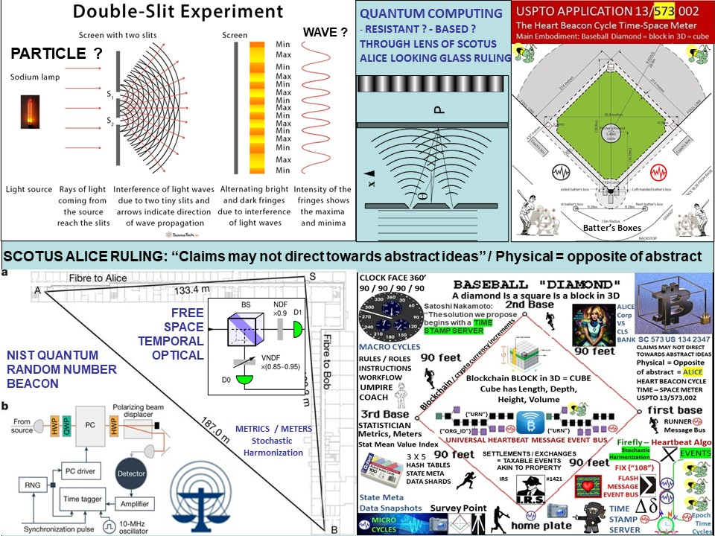

Figure 3: Quantum computing: Quantum resistant or quantum based or both?

Quantum Computing - Quantum Resistant, Quantum Based... particle or wave? Universal metrics, meters for myriad cryptocurrency blockchain memes, metaphors - what's your SCOTUS Alice Corp compliant meme?

QUANTUM COMPUTING: the use of quantum-mechanical phenomena such as superposition and entanglement to perform computation. Quantum computers are believed to be able to solve certain computational problems, such as integer factorization. in a quantum Turing machine, the difference is that the tape exists in a quantum state, as does the read-write head. This means that the symbols on the tape can be either 0 or 1 or a superposition of 0 and 1; in other words the symbols are both 0 and 1 (and all points in between) at the same time. While a normal Turing machine can only perform one calculation at a time, a quantum Turing machine can perform many calculations at once. The programmable economy will be anchored by quantum computing -for example, NIST's Quantum Random Number Beacon



Figure 4: Quantum computing compliant metrics, meters, syntax descriptions

1. Quantum Random Number Generator: The NIST method generates digital bits (1s and 0s) with photons, or particles of light, using data generated in an improved version of a landmark 2015 NIST physics experiment. That experiment showed conclusively that what Einstein described as "spooky action at a distance" is real. Researchers process the spooky output to certify and quantify the randomness available in the data and generate a string of more random bits.
2. The NIST Randomness Beacon Broadcasts a randomness pulse every 60 seconds Each pulse commits to a fresh 512-bit random string Each pulse is time-stamped and signed. Beacon periodically outputs a pulse containing 512 fresh random bits, time-stamped, signed and hash-chained. For example, each pulse also pre-commits to the randomness to be released in the next pulse. The latter enables users to securely combine randomness from different beacons. The Beacon protocol also specifies the interface for users to interact with the Beacon, in order to obtain information about past pulses. A randomness beacon produces timed outputs of fresh public randomness. Each output, called a pulse, includes metadata / cryptographic elements. The main goal of the NIST Random # Beacon is to serve as a baseline for deployment of many interoperable beacons NIST: <https://csrc.nist.gov/CSRC/media/Presentations/The-NIST-Randomness-Beacon-2-0/images-media/SciDay18-poster-beacon-v20181022.pdf>

NIST BOULDER Quantum Random Number Beacon | The BIG Bell Test: In 2015, NIST was one of the first groups to carry out a complete test of Bell theorem using quantum states of light, and conclusively show the presence of Einstein’s "spooky action at a distance." However, in that experiment the decisions about how to carry out the measurements were made by random numbers generated from different physical processes based on light photonics. <https://thebigbelltest.org/team/nist-boulder/>



Figure 5: NIST Quantum Random Number Beacon / USPTO 13/573,002

NON-REPUDIATION: Cryptocurrency units of value events, transactions non-repudiation at any time – space, place in the future will be expected required and will be derived from a physical (photonic) light process generated by a Quantum Random Number Beacon QRNB. The QRNB provides a method and means to prevent repudiation of any event, transaction at any point in time – space.

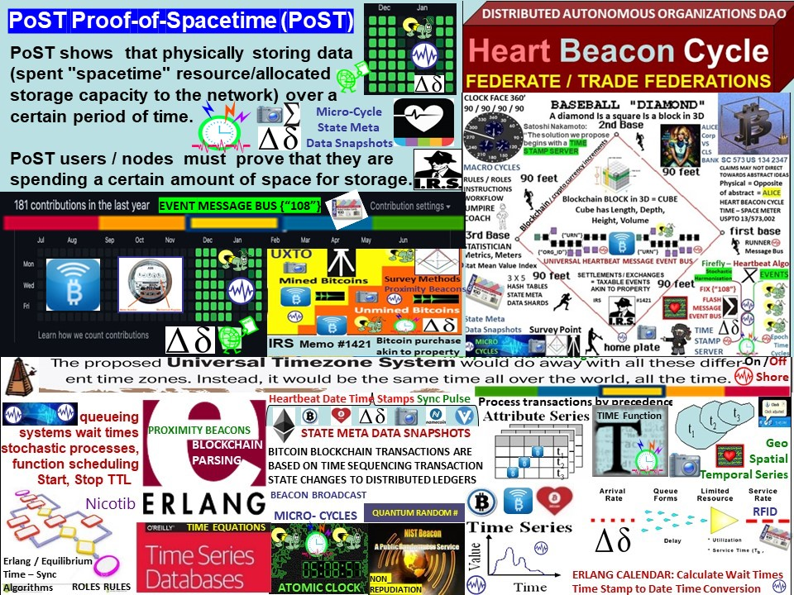

Figure 6: Proof of Space – Time / Heart Beacon Cycle Time – Space Meter

Proof-of-spacetime differs from proof-of-capacity in that PoST allows network participants to prove that they have spent a "spacetime" resource, meaning that they have allocated storage capacity to the network over a period of time. The creators of Proof-of-Spacetime, Tal Moran and Ilan Orlov, called this 'Rational' Proofs of Space-Time because the true cost of storage is proportional to the product of storage capacity and the time that it is used.



Figure 7: Beacon Communities in a DATF Distributed Autonomous Trade Federation

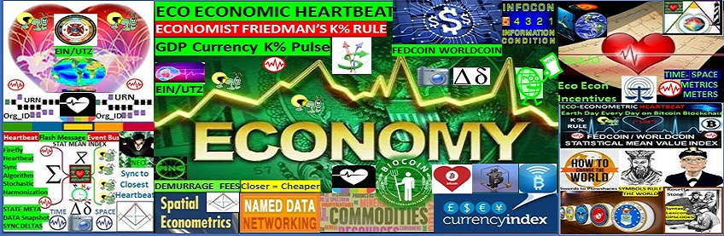

Figure 8: Economy system of systems framework / How to save the world

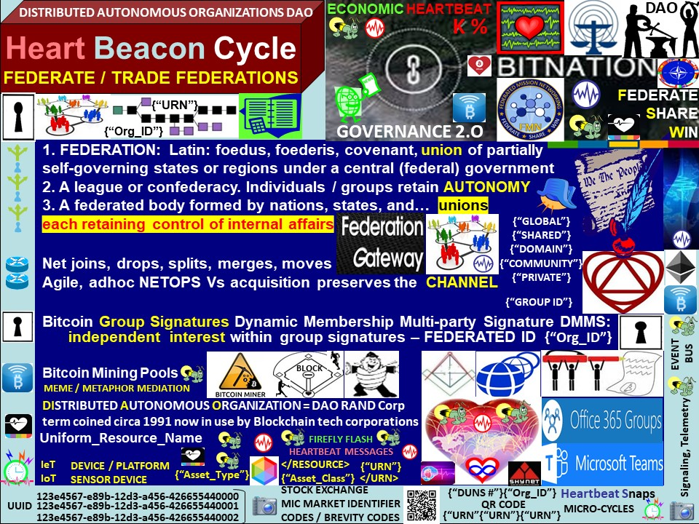

Figure 9: Federate and graduation on the cryptocurrency blockchain

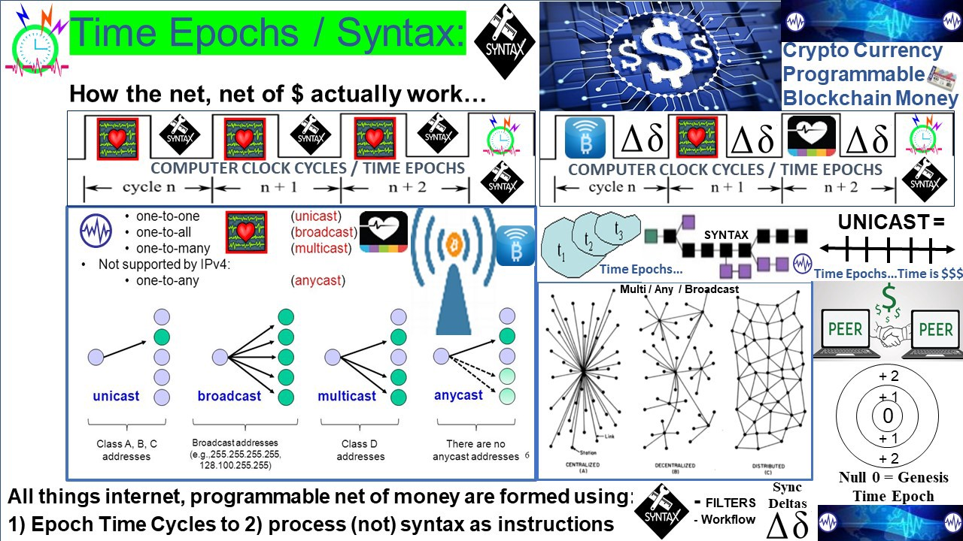

Figure 10: Epoch Time Cycles used / not used to process syntax as instructions

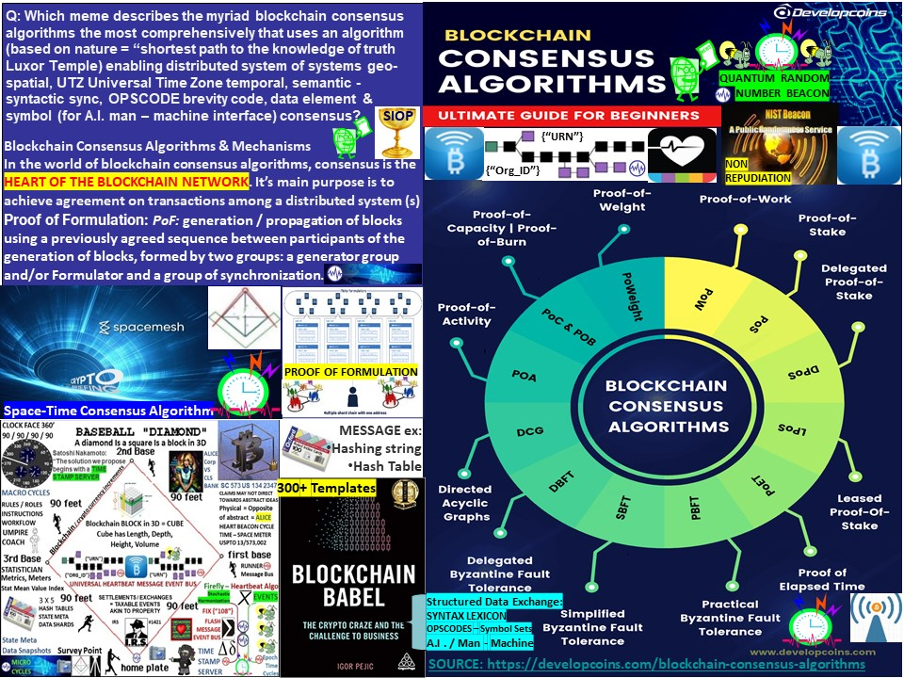

Fig 11: Consensus among many consensus algorithms proof of work, stake, time, space

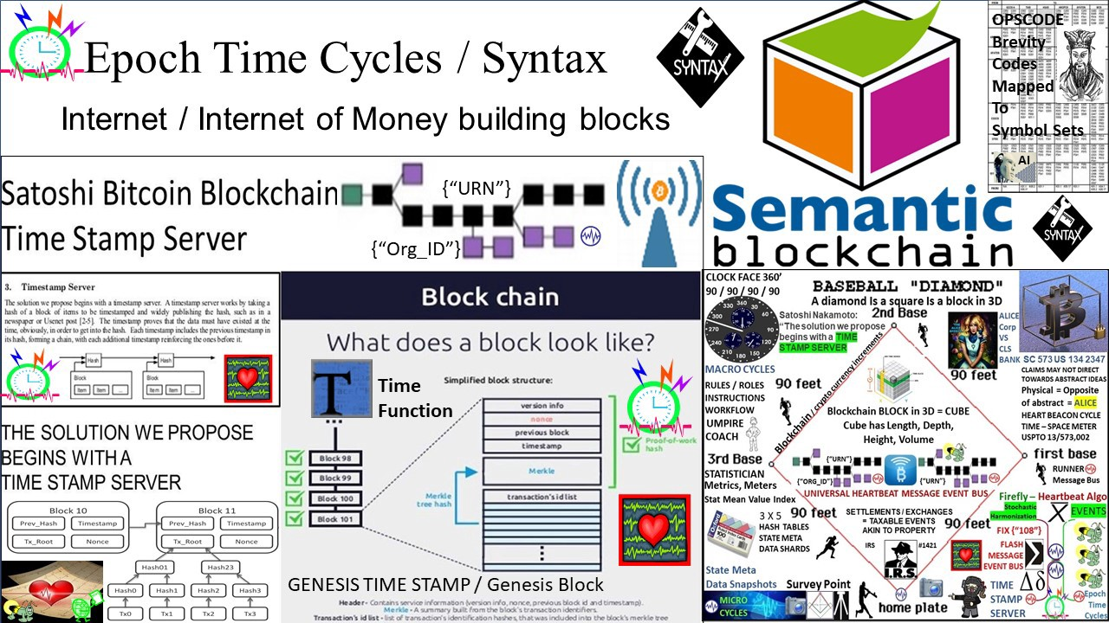

Figure 12: The semantic web and the crypto blockchain = time epochs / syntax lexicon



**Figure 13 FEDCOIN / WORLD COIN**

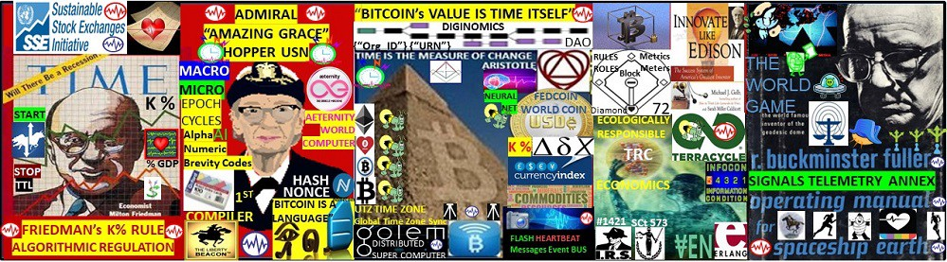

Fig 16: Eco sustainable Economic Epoch Heartbeat : Standing on the shoulders of giants

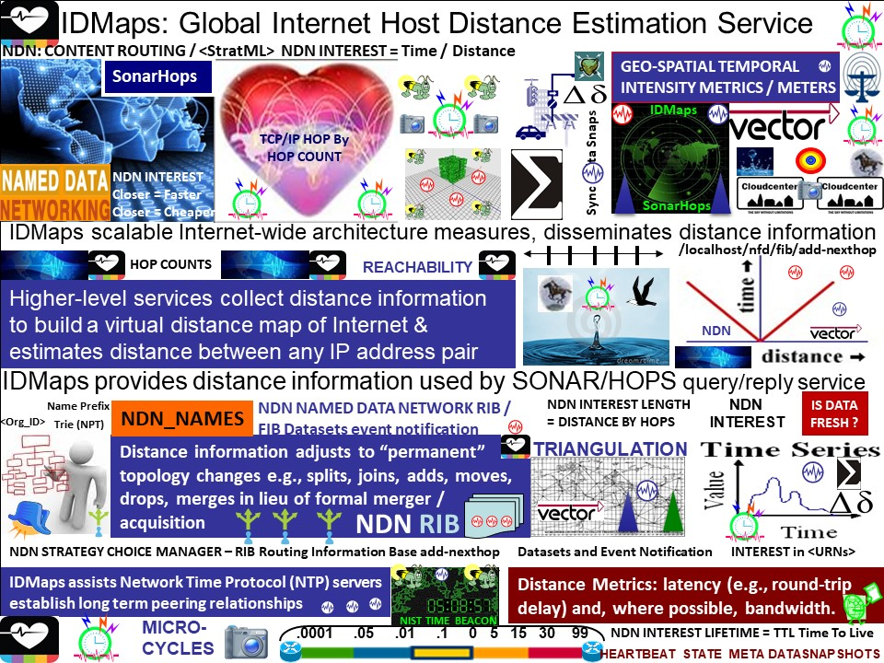

Figure 17: Time – Space metrics, meters: IDMaps, SonarHops

IDMaps: A Global Internet Host Distance Estimation Service: scalable Internet-wide architecture, called IDMaps, which measures and disseminates distance information. Higher level services can collect such distance information to build a virtual distance map of the Internet and estimate the distance between any pair of IP addresses.

SonarHops: Service query / reply service (SONAR) HOPS (Host Proximity Service) like a DNS query/reply obtaining distance information provide distance information in terms of latency (e.g., round-trip delay) and, where possible, bandwidth)

IEEE 802.11AG is used for hop by hop detection and control for epoch assignment and hop counts management and for hop by hop detection function to determine hop by hop count corresponding to machine readable and executable null / 0 and steps from null representing hop counts e.g., +1, +2, +3, +4 and / or -1, -2, -3, -4 Paul Revere linear, sequential metaphor indicating distance traveled in context with router / server / switch / node traversal. IEEE 802.11 HbH hop by hop control described, represented by USPTO 13/573,002 Paul Revere, rain drop in pond meme - metaphor metrics denoting increases / decreases in thresholds intensity, duration and hop count sums

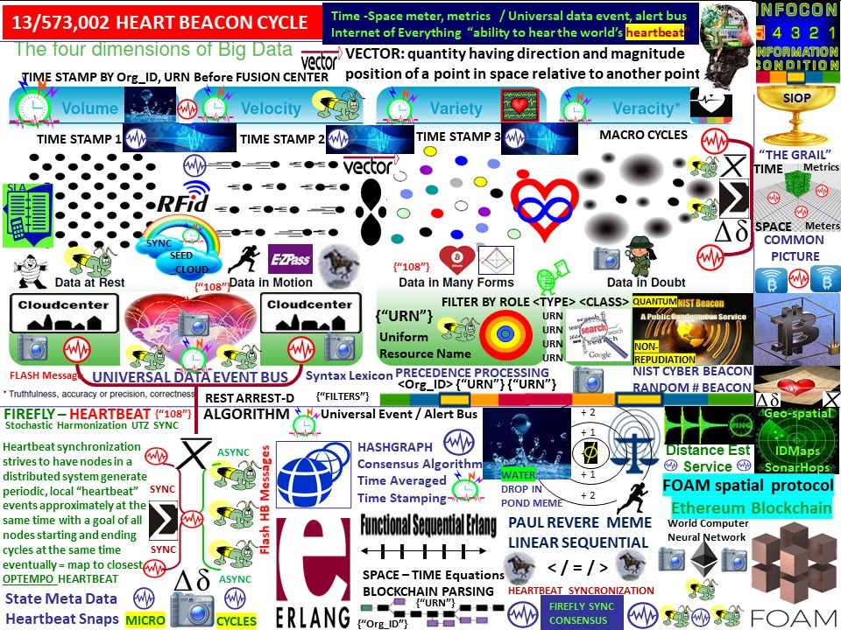

Figure 18: Big Data The Next Oil

Big Data as the “Next Oil”: Establishing a consistent <tag> context library / lexicon and time stamping data by organization <Org_ID> and by data class type and by resource type to form a universal syntax, code, date element, tag Rosetta Stone and reference for coders, programmers. A adaptive procedural template used to improve signaling, synchronization using TCP/IP heartbeat time stamping occurring during micro-cycles of state meta data prior to data fusion center entry among metrics, metering processes comprised of TCP/IP heartbeats, heartbeat messages signaled during micro-cycles scheduling instructions, commands, processes, procedures, algorithms, telemetry instructions for example, to master-controller processes i.e., block, start, stop, pause, resume, set Time To live TTL i.e., stock market high frequency flash trade, currency, interest rates, tax rates, time banking, cloud computing commodity exchanges, big data, electrical micro-grid, fungible goods, real time bidding, many use cases. Time stamping and applying descriptive data type tags to heartbeat state meta data after data is collected and queued, stored in temporary structures or entered into data base instantiations after the fact is problematic. All internet supported devices including high frequency stock, currency, commodity etc., flash trade master controllers receive heartbeats. Heartbeats are silicon chip created intervals, epochs, time cycles used to (not) process syntax.

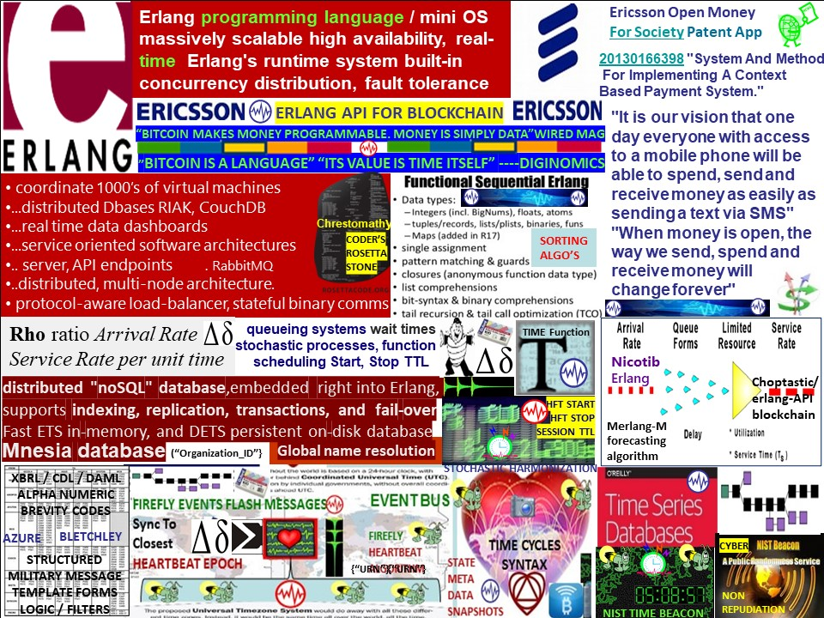

Figure 19 Erlang Time Equations / USPTO 13/573,002 universal net, net of $ metrics, meters

ERLANG – ERLANG FOLSOM: Erlang based metrics system inspired by Coda Hale's metrics (https://github.com/dropwizard/metrics). The metrics API's purpose is to collect real-time metrics from Erlang applications and publish them via Erlang APIs and output plugins. folsom is not a persistent store. There are 6 types of metrics: counters, gauges, histograms (and timers), histories, meter readers and meters. Metrics can be created, read and updated via the folsom metrics module. <https://github.com/boundary/folsom>

Erlang logic is useful in establishing time boundaries and time limits among geo-spatially disperse events. The Paul Revere linear-sequential meme – metaphor is a physical meme used instead of an abstract metaphor that the internet uses called TCP/IP “hop counts”. Hops are linear and sequential referring to applicant's Paul Revere meme (126). Hops are described / defined from null as a condition / state: stationary, inactive. Hops are changes in location from point a to point b to point n. are referential to TCP/IP in embodiment 1. Hops are counted incrementally where hops are changes in location e.g., home plate to first, second, and third base and back to home base (131). Hop metrics are incremental changes from null 0,1,2,3,4 - N (126) that may be positive or negative values. Hop counts are used to equitably meter, measure and derive performance or effectiveness metrics, meters. Time stamps (112) form time frames, temporally bound hops e.g., in time and space.

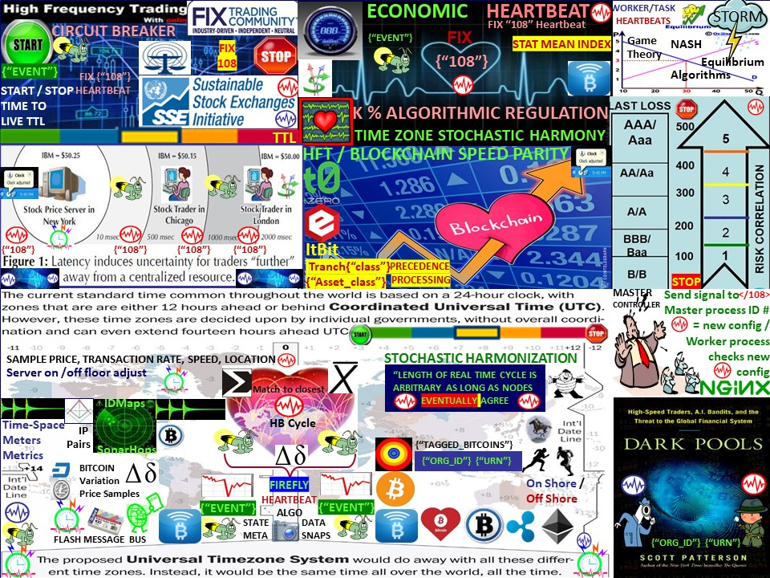

Figure 20: High Frequency Trade HFT Flash Trade Circuit Breaker / Limiter

STOCK / COMMODITY MARKETS given QUANTUM COMPUTING: other than the ubiquitous </108> {"108"} heartbeat message sending start, stop, TTL Time To Live commands to algorithmic HFT trade to master controllers, how will stock, commodity, crypto etc. markets be mitigated, moderated among the quantum computing haves / have nots?, how will market trade sessions be mitigated, moderated among quantum haves and have nots? i.e., QCCS Quantum Computing Control System

Heartbeat ¶ In standard FIX, when either end of the FIX connection has not received a message in HeartBtInt (108) seconds, a heartbeat message will be transmitted (MsgType 0). As noted above, the default value for HeartBtInt is 30 seconds.

The Heartbeat <0> monitors the status of the communication link and identifies when the last of a string of messages was not received. When either end of a FIX connection has not sent any data for [ HeartBtInt <108>] seconds, it will transmit a Heartbeat <0> message. When either end of the connection has not received any data for ( HeartBtInt .



Figure 21: Adaptive Procedural Template checklist snapshot summary



Figure 22: Adaptive Procedural Template checklist USPTO 13/573,002

Eco sustainable Economic Epoch Heartbeat for programmable $$$ / Economy: It's TIME.

The Heart Beacon Cycle Time – Space Meter: it's about Time - Space and a syntax lexicon Rosetta Stone library derived from DoD / NATO system of systems engineering best practice

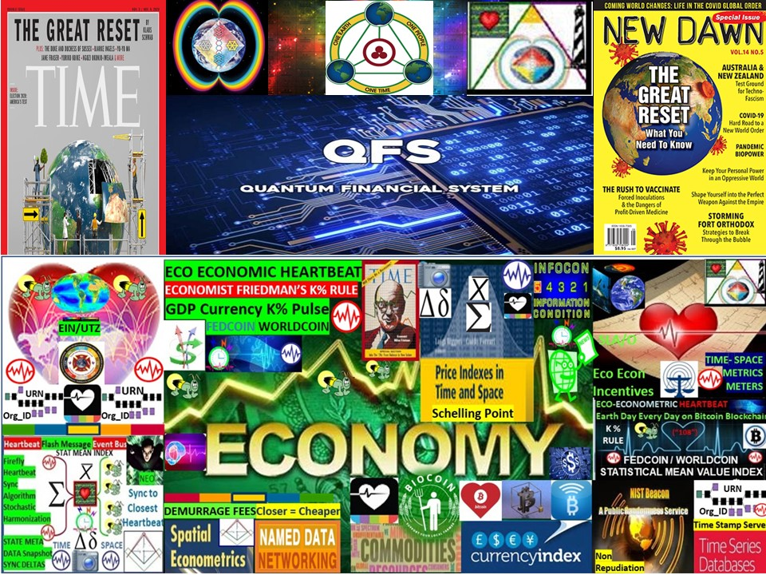

Fig 23: Great, Greater Resets // Eco Economic Epochs for the programmable economy

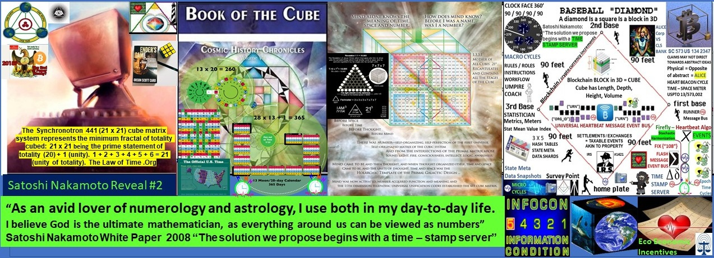

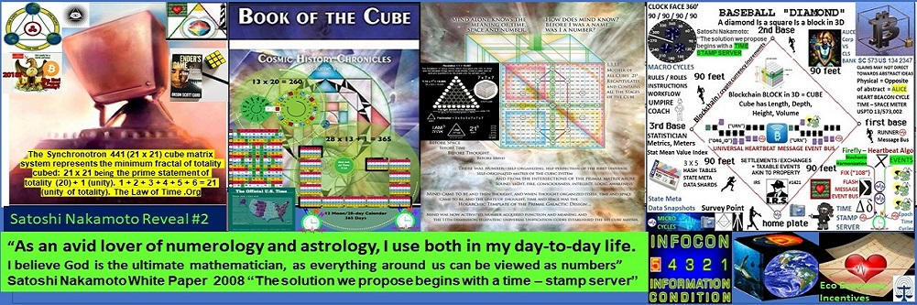

Figure 24: Satoshi Nakamoto reveal #2 / Sacred Geometry / Crypto currency meme

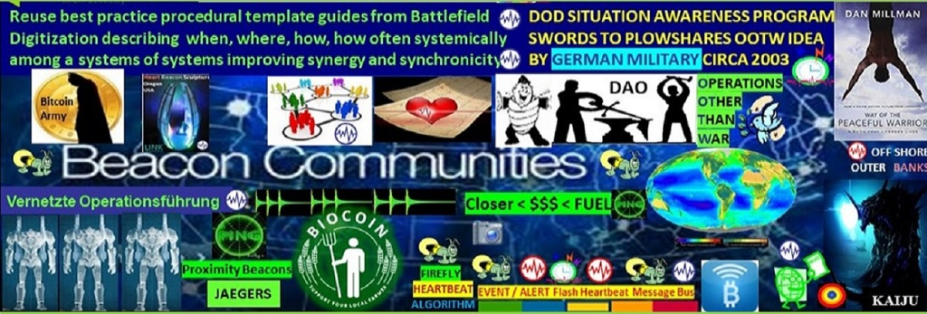

Figure 25 German Army OOTW Operations Other Than War



Figure 25: Business Card, files, contact information // How to save the (economic) world